ANNUAL FISHWAY
STATUS
REPORT

For

BONNEVILLE DAM

2001

By

Jennifer D. Sturgill
Tammy M. Mackey
Terry W. Hurd

U. S. Army Corps of Engineers
CENWP-OP-B
Bonneville Lock & Dam
Cascade Locks, OR 97014
(541) 374-8375

7 December 2001
TABLE OF CONTENTS

Introduction
2
FISHWAY oPERATION AND aCTIVITIES 3
FISH PASSAGE PLAN (FPP) VIOLATIONS 4
Auxiliary Water System (AWS) Closures 5
Fish UNIT Outages 5
Fish FACILITY Outages and Maintenance 5
TURBINE OUTAGES AND DEWATERINGS 6
fISH REMOVAL 6-7
VBS/STS INSPECTIONS
Table 1. Submersible Traveling Screen (STS)and Vertical Barrier Screen (VBS) Inspections 8
ZEBRA Mussels 8
GLOSSARY 9
REFERENCES 10

INTRODUCTION

This document summarizes activities impacting fish at Bonneville Lock & Dam from 1 December 2000 through 30 November 2001.

Primarily a summary of weekly reports, this document is required by the Corps of Engineers’ North Pacific Division, as described in the Fish Passage Plan (FPP) . The FPP contains the following surveillance and reporting requirements. “Project biologists shall inspect fish passage facilities at the frequencies listed in the juvenile and adult fish facilities operating criteria sections. The (weekly) reports shall include: any out of criteria situations observed and subsequent corrective actions taken; equipment malfunctions, breakdowns or damage, along with a summary of resulting repair activities; adult fish control calibrations; STS and VBS inspection; any unusual activities which occurred at the project which may affect fish passage.”

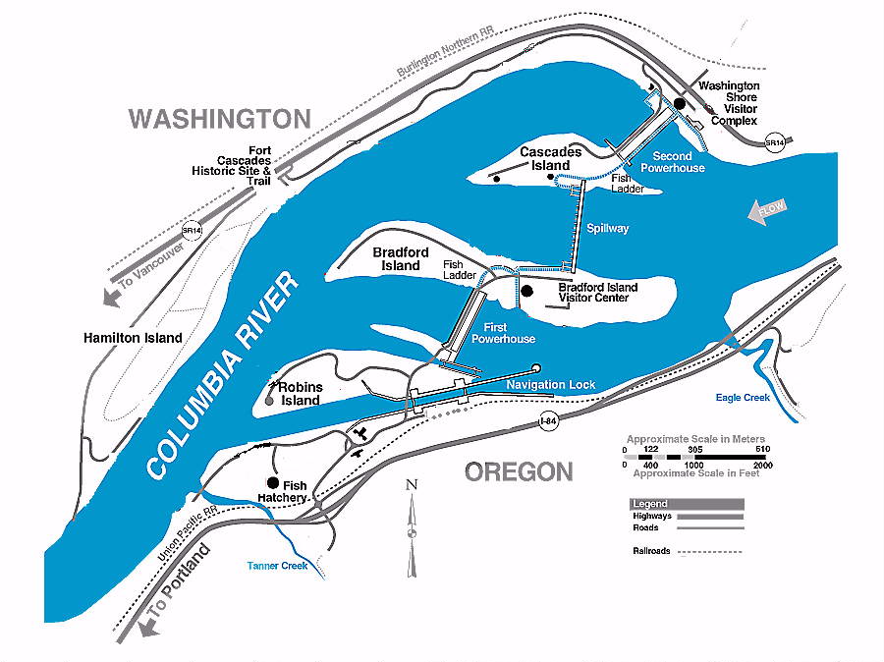

Figure 1 Bonneville Lock & Dam.
The project and fish passage facilities are described in the Fish Passage Plan¹. In summary, the project comprises two powerhouses, a spillway and two navigation locks. The older of the two navigation locks has not operated since early 1993. There are four adult fish ladders for upstream migration, one at PH1, one at the south end of the spillway, one at the north end of the spillway and one at PH2. There are two Juvenile Bypass Systems for downstream migration, one at each powerhouse.
Acronyms and jargon are used freely in this report. The reader can find definitions in the glossary.

FISHWAY OPERATION AND ACTIVITIES
Fish Passage Plan (FPP) Violations

The results of 279 daily fishway inspections (24 of which were conducted by NMFS, FPC, or CRITFC Salmon Corps) are shown in the following table. The FPP requires three inspections a day during fish passage season. Project Fisheries conducts two inspections each day and the control room conducts the third. Shown are the FPP violations, numbers of days the violation occurred, and the percentage of days the item was IN criteria.

Auxiliary Water System (AWS) Closures

The AWS’ were closed for trashrack cleaning on several occasions during the 2000-2001 reporting year. Closures ranged from six minutes to over five hours with an average closure lasting 39 minutes. AWS trashracks were usually cleaned once each month with more frequent cleanings during late summer and early fall. This year FV3-9 had 30 closures with an average of 18 minutes per cleaning. FV3-7 had six closures with average closure time of 58 minutes. FV1-1 was closed 14 times with an average closure lasting 41 minutes. Mid season dives and ladder outages are not included in cleaning closure times.
FV4-3, FV4-4, FV5-3 and FV5-4 were occasionally closed for up to 12 hours to facilitate dissolved gas abatement construction operations, Bradford Island hazardous waste cleanup, research equipment installation, and mid-season fishway inspection dives.

Fish Unit Outages

Fish Unit 1 (F1) was out of service from 08 January 01 until 27 February 01 for annual maintenance and to facilitate PH2 ladder dewatering.
Fish Unit 2 (F2) was out of service from 18 December 00 until 28 February 01 for annual maintenance and to facilitate PH2 ladder dewatering.
Fish units 1 and 2 were placed on standby at other times during the year to “float” trash away from the trash racks. When drawdown measured one foot or greater, fish units were shut down. An adjacent unit was then operated to pull trash away from the fish unit trashracks. This procedure helped prevent debris and silt from accumulating in front of the fish units. Most of the unit outages associated with the floating of trash and debris occurred between midnight and 0300 to minimize impact on adult fish passage.
Between 1 December 2000 and 30 November 2001 there were a total of 7560 hrs for unit F1, and 7032 hrs for unit F2 during which no downtime was reported.

Fish Facility Outages & Maintenance

03 Dec 00 – 08 Jan 01 Bradford Island ladder OOS for winter maintenance.
18 Dec 00 – 26 Feb 01 DSM1 OOS for winter maintenance.
03 Jan 01 - 27 Feb 01 AFC&MF OOS for winter maintenance.
09 Jan 01 – 27 Feb 01 Washington shore ladder OOS for winter maintenance.
23 Jan 01 – 27 Feb 01 Cascades Island ladder OOS for winter maintenance.
29 Jan 01 – 08 Mar 01 DSM2 OOS for winter maintenance.
04 Oct 01 DSM1 OOS to conserve water and for winter maintenance.
29 Nov 01 – 07 Dec 01 AFC&MF OOS for Adult PIT work.

Turbine Outages and Dewaterings (outages of at least 24 hours)

Date Unit Reason for Outage

All year 3 Turbine rehab
08 Jan 01 – 12 Jan 01 16 Servomotor repair
27 Jan 01 – 28 Jan 01 2 Drain oil thrust bearing
29 Jan 01 – 01 Feb 01 6 High lift pump check valve replacement
29 Jan 01 – 19 Apr 01 15 Gate slot modifications
05 Feb 01 – 09 Feb 01 4 Thrust bearing work
26 Feb 01 – 28 Feb 01 1-10 STS installation
26 Feb 01 – 28 Feb 01 12-16 STS installation
08 May 01 – 09 May 01 8 Replace ESBS electric motor
21 May 01 – 24 May 01 2 Roof disconnect work
28 May 01 – 02 Jun 01 1 Pre-rehab work
29 May 01 – 10 Oct 01 17 Four-year overhaul
04 Jun 01 – 07 Jun 01 2 Roof disconnect work
11 Jun 01 – 22 Jun 01 2 Semi-annual maintenance & switchyard disconnect work
12 Jun 01 – 14 Jun 01 5 Rehab inspection
18 Jun 01 - ongoing 5 Rehab work
23 Jun 01 – 26 Jun 01 15 STS stuck in gatewell B
16 Jul 01 – 26 Jul 01 6-8 Roof disconnect work
14 Aug 01 – 20 Aug 01 9 Roof disconnect work
03 Sep 01 – 08 Sep 01 7-8 Bank 7/8 bushing replacement
04 Sep 01 – 08 Sep 01 6&9 Roof disconnect work
10 Sep 01 – 21 Sep 01 6 Efficiency testing
10 Sep 01 – 20 Sep 01 9 Roof disconnect work
12 Sep 01 – 20 Sep 01 4 Contractors setting up for testing
15 Sep 01 – 20 Sep 01 10 Switching work
24 Sep 01 – 02 Oct 01 9 Bank 9/10 work
12 Oct 01 – 13 Oct 01 7 Switching work
15 Oct 01 – 14 Nov 01 15 Four-year overhaul
19 Nov 01 – 20 Nov 01 8 Five-year overhaul
21 Nov 01 – 29 Nov 01 16 Governor leak

Fish Removal 2000/2001

Fish passage facilities and turbine units are taken out of service and dewatered to allow for inspection, preventative maintenance, repairs, and modifications. As facilities and turbine units are dewatered, project biologists, outside agency personnel, and other project personnel follow procedures outlined in the FPP and detailed in the Fish Removal Plan to minimize impacts to fish. Fish recovered are typically released into the forebay above the new navlock however, sturgeon and juveniles are released below the dam at Hamilton Island. The following is a summary of the number of fish that were removed during facility and turbine unit dewaterings. All fish were recovered in good condition unless otherwise noted.

Unit 2 tail logs (12-01-00): 1 sturgeon, 15 sculpin.

Bradford Island ladder junction pool (12-05-00): 10 wild steelhead, 11 hatchery steelhead, 11 rainbow trout, 2 wild coho, 1 hatchery coho, 1 wild chinook, 5 hatchery chinook, assorted resident fish, and shad.

Bradford Island ladders A-branch (12-05/06-00): 1 dead hatchery steelhead, 1 juvenile steelhead, 1 sucker, 2 wild fall chinook juveniles, 5 whitefish and peamouth.

Bradford Island ladder B-Branch (12-07/08-00): 4 sculpin, 3 whitefish and peamouth, 1 fall chinook juvenile, 7 live lamprey, and 1 dead lamprey.

DSM 1and JBS channel (12-18-00): 6 juvenile salmonids, 12 adult steelhead, 1 whitefish, 1 Northern pikeminnow, and 21 sculpin.

FG3-12 (12-27-00): 1 juvenile steelhead, 12 lamprey, 1 sucker, 1 whitefish, 1 catfish, 2 sculpin.

AFF (01-03-01): 156 adult steelhead, 6 juvenile steelhead, approx. 12 resident fish.

Washington Shore ladder (1-09-01): 42 adult steelhead.

Cascade Island upper ladder (01-23-01): 18 adult steelhead, 1 juvenile salmonid, 15-20 resident fish.

Cascades Island entrance (01-25-01): 1 adult salmon and 6 sculpin.

South Monolith Powerhouse 2 (1-26-01): 1 juvenile hatchery chinook.

North Monolith Powerhouse 2 (2-02-01): 4 hatchery winter steelhead, 6 wild winter steelhead (4 dead 2 alive), 8 resident fish (3 dead 5 alive).

Upstream Navlock sill (3-06-01): 1 juvenile spring chinook.

Unit 15 tail logs (4-18-01): 3 channel catfish and 5 sculpin.

Unit 17 draft tube (5-31-01): 28 sturgeon, 5 channel catfish, 1 sculpin, and 3 dead juvenile chinook.

Unit 5 draft tube (6-20-01): 6 lamprey, 6 live sturgeon, and 3 dead sturgeon.

Spill Bay 17 (10-04-01): removed 1 dead sturgeon.

DSM1 (10-04-01): 6 sculpin, 4 crayfish, 1 bass, and 1 unclipped juvenile steelhead.

Unit 15 draft tube (10-16-01): 23 sturgeon, 2 peamouth, and 1 channel catfish.

Unit 15 tail logs (11-6-01): 13 channel catfish and 2 sculpin.

AFF entrance ladder and collection pool (11-29-01): 12 steelhead, 2 whitefish, 3 shad and 1 juvenile salmonid.

VBS/STS Inspections

The Fish Passage Plan requires STS inspections be conducted monthly, and VBS inspections once every two months. Because each STS has a timer that automatically shows elapsed time of operation, STS inspection frequency can be measured by run time. The equivalent of one month of continuous operating time is 720 hours. Bonneville inspects both STS and VBS with an underwater video camera. Video allows STSs and VBSs to be inspected simultaneously, and eliminates the need to dip gatewells and handle fish.

Table 1. Submersible Traveling Screen (STS) and Vertical Barrier Screen (VBS) Inspections 2000-2001

Zebra Mussels

Through weekly inspections of the monitoring station at the First Powerhouse and of all dewatered fishways, we have found no indication of zebra mussel colonization. It is understood that their arrival is inevitable. We continue monitoring with hopes that control programs can be initiated at the first indication of the zebra mussel’s arrival in the Pacific Northwest.

GLOSSARY
AFC&MF Adult Fish Collection and Monitoring Facility. The building attached to the second powerhouse main fish ladder where adult fish are trapped for monitoring or removal. Also known as the AFF.
AFF----------------See AFC&MF.
BiOp Biological Opinion.
BON Bonneville Lock & Dam.
Downwell Opening through which water and fish drop after excess water is drawn away through a dewatering screen. It is the beginning of the conduit that delivers fish from the DSM to the tailrace at PH1.
DSM 1 Downstream Migrant transportation channel (PH1). The channel in the PH1 juvenile fish bypass system that transports fish from the gatewell orifices to the downwell.
DSM 2------------Downstream Migrant transportation channel (PH2). The channel in the PH2 juvenile fish bypass system that transports fish from the gatewell orifices to the juvenile transport pipe.
CRITFC Columbia River Intertribal Fish Commission.
FFU Fisheries Field Unit. Unit in the Corps of Engineers’ Portland District Construction, Operations Division that conducts fish related evaluations and monitoring.
FGE Fish Guidance Efficiency. Proportion of fish entering turbine intakes that are guided into the juvenile bypass system.
Forebay That area of a reservoir immediately upstream of a dam.
FPC Fish Passage Center.
FPE Fish Passage Efficiency. Proportion of juvenile fish that pass the dam by non-turbine routes.
FPP Fish Passage Plan.
JBS Juvenile Fish Bypass System. Usually refers to PH2.
JMF Juvenile Fish Monitoring Facility. A laboratory building at the end of the PH2 JBS.
Kcfs Thousand cubic feet per second.
NDE North Downstream Entrance. Refers to one of the four large overflow weir adult fishway entrances at PH2.
NUE North Upstream Entrance. Refers to one of the four large overflow weir adult fishway entrances at PH2.
NMFS National Marine Fisheries Service.
ODFW Oregon Department of Fish & Wildlife
OOS Out Of Service.
PCC Powerhouse Collection Channel. The part of the adult fishways which spans the length of the downstream side of each powerhouse. Fish swim through it to reach the base of the fish ladder.
PH1 Bonneville First Powerhouse.
PH2 Bonneville Second Powerhouse.
PIT-----------------Passive Integrated Transponder. A tag inserted into juvenile and adult fish. Detectors are installed at DSM1, DSM2, AFC&MF, and in the adult fish ladders.
Project Bonneville Lock & Dam.
SDE South Downstream Entrance. Refers to one of the four large overflow weir adult fishway entrances at PH2.
SUE South Upstream Entrance. Refers to one of the four large overflow weir adult fishway entrances at PH2.
STS Submersible Traveling Screen.
Tailwater The portion of a river immediately downstream of a dam or powerhouse.
TIE Turbine Intake Extension.
Tule Early spawning fall chinook.
UMT Upstream Migrant Transportation channel. This channel passes through the second powerhouse and connects Cascades Island ladder to Washington shore ladder.
VBS Vertical Barrier Screen.
WDFW Washington Department of Fish & Wildlife.

REFERENCES ? _____. 2000. Fish Passage Plan for Corps of Engineers Projects. U. S. Army Corps of Engineers, North Pacific Division, Portland, Oregon.
Sturgill, J.D., . 2002. Bonneville Dam Fish Removal Plans.

